ServiceNow Certified Application Developer
SmartInternz

Project Title
ServiceNow-Based Employee Laptop Request Application
Platform | ServiceNow
Application Area | Service Catalog and Flow Designer
Primary Catalog Item | Laptop Request
Backend Table | Laptop Request Table
Automation | Flow Designer
Document Type | Project Implementation Report

Name: BHARGAVI CHALLAGUNDLA
College: CHALAPATHI INSTITUTE OF TECHNOLOGY
Email: 23HT1A0526@city.ac.in

Milestone 1 — Update Set Creation & Project Initialization
- Navigate: All → System Update Sets → Local Update Sets.
- Click New and create an Update Set named HR Onboarding Application.
- Set the State to In Progress.
- Click Make This My Current Set.
- Start developing the project components such as tables, fields, forms, business rules.
- Verify that all changes are captured in the Customer Updates section.
Milestone 2 — Custom Application Creation
- Navigate to All → System Applications → My Company Applications.
- Click New and its named as Project application.
- Define the Application Scope and access settings.
- Verify that all project components are created within the application scope.
Milestone 3 — Table Design & Data Model Configuration
- Created the Laptop Request Form custom table.
- Added Auto-number, Reference, and Choice fields.
- Configured field validations and data consistency.
Milestone 4 — Request Logic & Business Rules Setup
- Created Business Rules for request processing.
- Restricted employees to one laptop request per year.
- Added validations and duplicate-request error handling.
Milestone 5 — Validation, Testing & Readiness for Automation
- Tested the complete laptop request creation process.
- Verified field behavior and choice values.
- Confirmed all changes were captured in the Update Set.

Update Set & Application Creation.
- Navigate: All → System Update Sets → Local Update Sets.
- Click New → enter the Update Set name HR Onboarding Application.
- Set State: In Progress, add the required details, and click Submit.
- Open the Update Set and click Make Current.
- Navigate: All → ServiceNow Studio.
- Click Create Application → enter Project Application.
- Select Scoped Application → click Continue.
- In the application, go to Data → Tables and create the required custom table with the project fields.

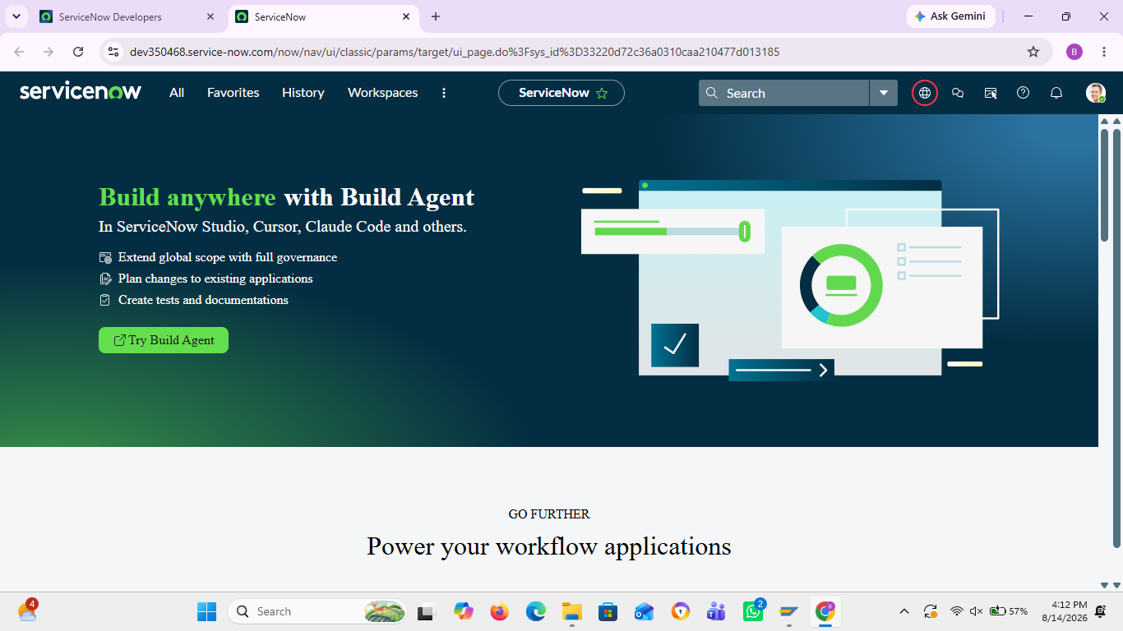

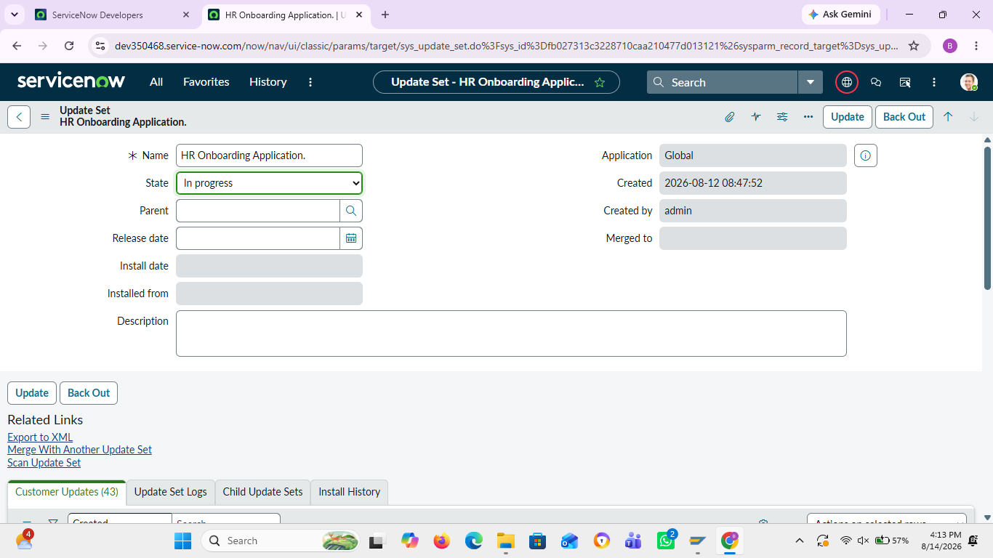
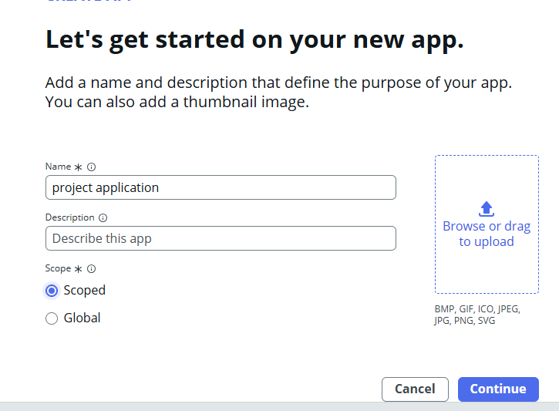
Laptop Request Form Table Creation
- Navigation: ServiceNow Studio → Project Application → Data → Tables.
- Click New to create a new table.
- Enter the table name as Laptop Request Form.
- Configure the required table settings and click Submit/Save.
- Open the Laptop Request Form table and add the required fields.
- Configure fields such as Employee, Request Type, Reason, Status, Request Date, and Laptop Details.
- Save the fields and verify that they are displayed correctly on the table form.
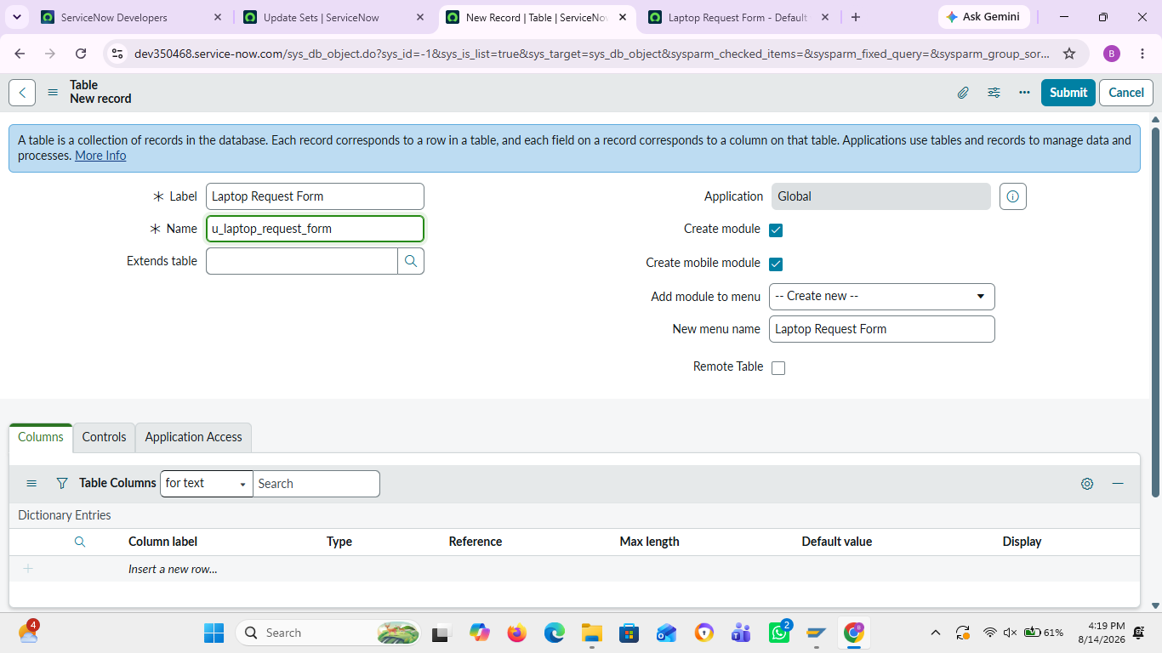

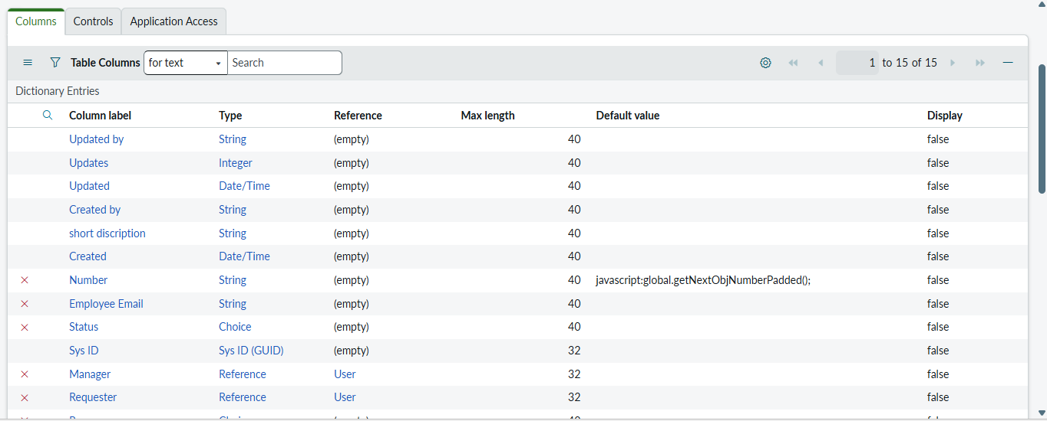
Service Catalog Creation.
- Navigate: Service Catalog → Catalog Definitions → Maintain Items.
- Create a Catalog Item named Employee Service Catalog and select Service as the category.
- Add the Laptop Request Record Producer to the Employee Service Catalog.

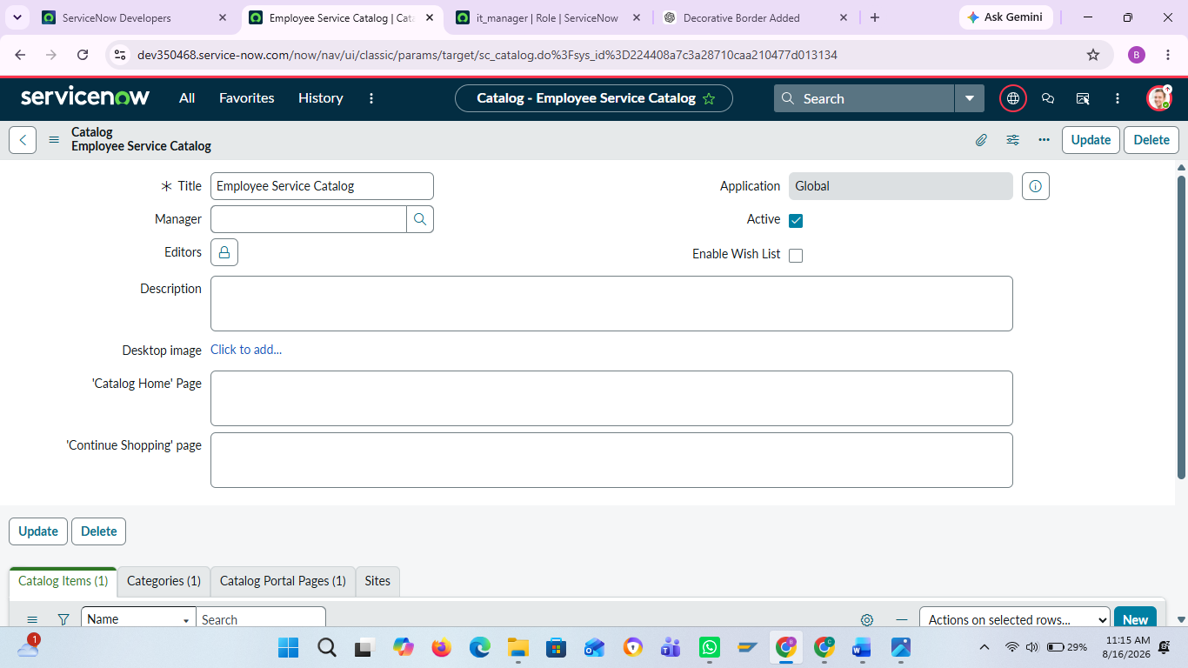
Record Producers creation
- Navigate: Service Catalog → Catalog Definitions → Record Producers.
- Click New and create a Record Producer named Laptop Request.
- Select Laptop Request Form as the target table.
- Add variables matching the required table fields and map them to the corresponding fields.
- Save the Record Producer.
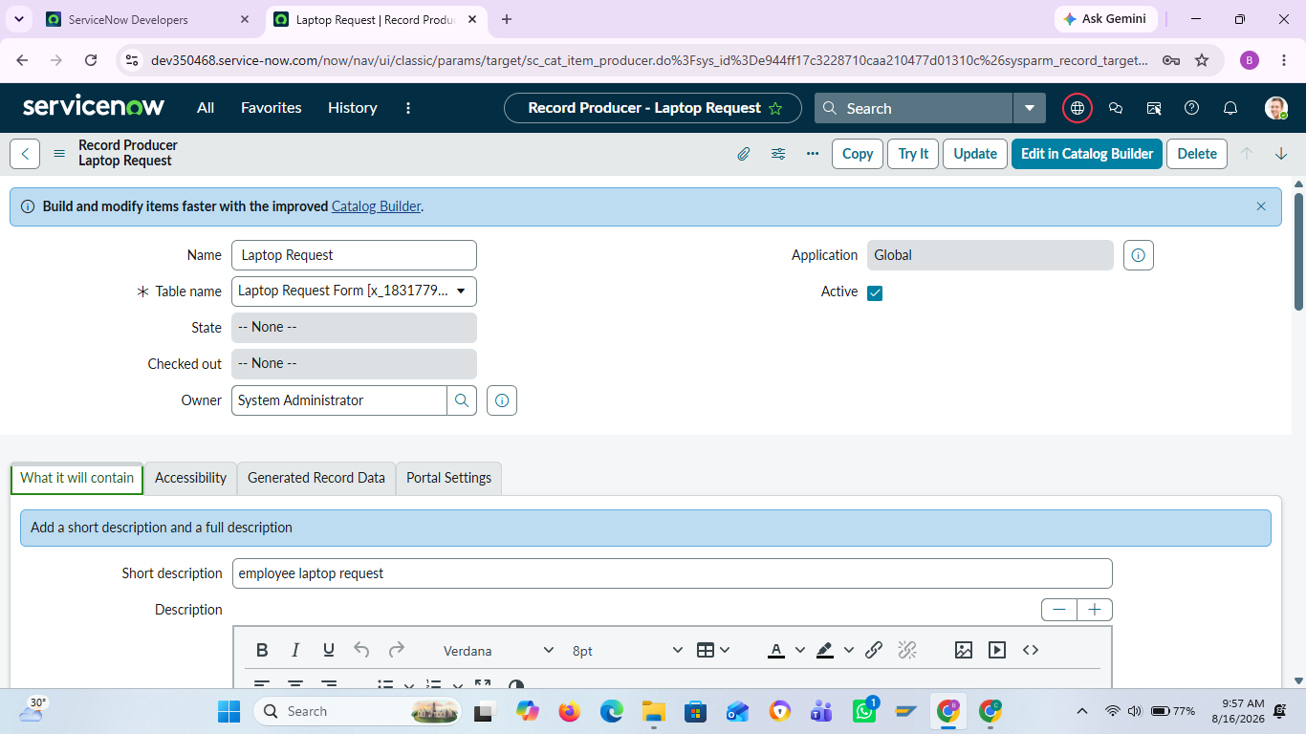
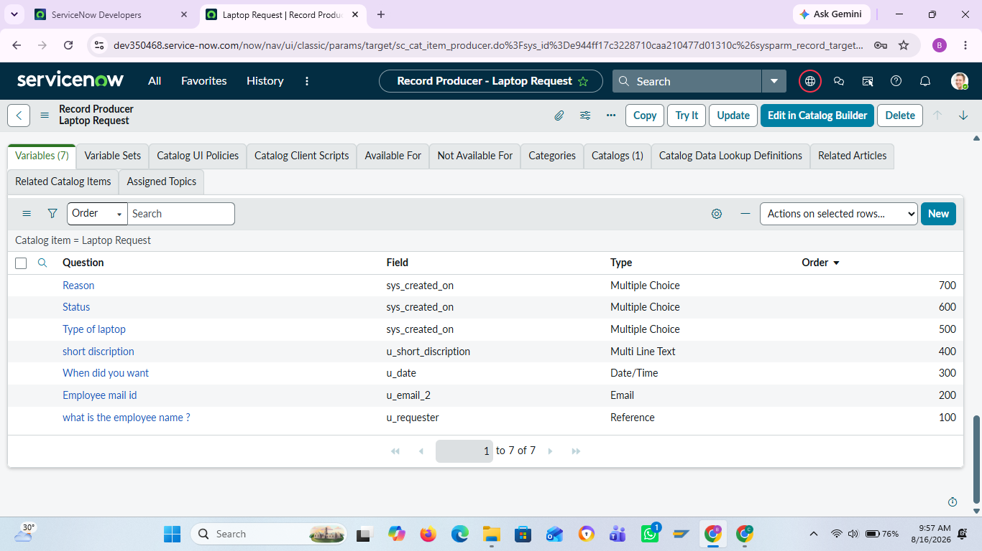
Flow Designer Automation
Purpose: Automate the complete laptop request approval process and reduce manual work.
Trigger:
- Navigate: Flow Designer → New Flow
- Select Record Trigger.
- Table: Laptop Request Form.
- When: Record is Created.
Process:
- Automatically send the request for Manager Approval.
- Update the request Status based on approval or rejection.
- Send Email Notifications at each stage.
- Complete the process automatically without manual intervention.
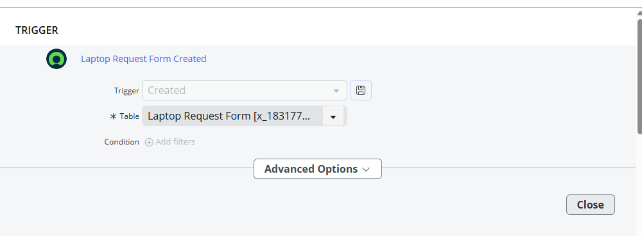
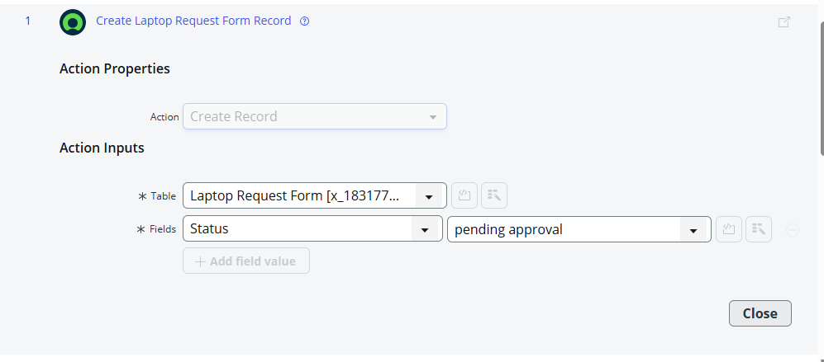
Action — Update Record
Navigation: Flow Designer → Actions → Update Record
- Select the Laptop Request Form record.
- Set Status to Pending Approval.
- This automatically assigns the initial status to every new request.
- It avoids manual status updates and keeps the process consistent.

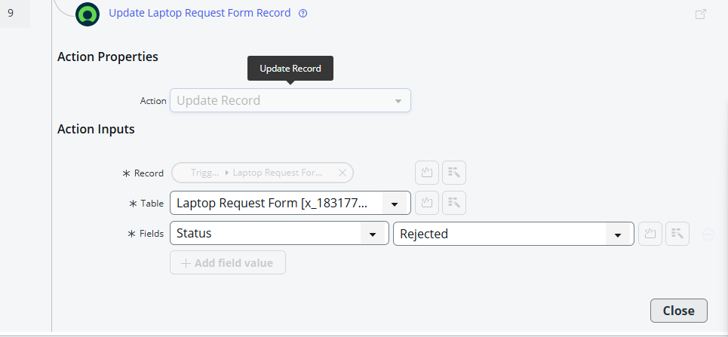
Approval, If/Else & Email Automation
- Navigate: Flow Designer → Actions → Ask for Approval.
- Select the Laptop Request Form record and send it to the Manager for approval.
- Add If/Else condition to check the approval result.
- If Approved: Update status to Approved and send an approval email.
- If Rejected: Update status to Rejected and send a rejection email.
- Navigate: Flow Designer → Actions → Send Email to configure the notifications.

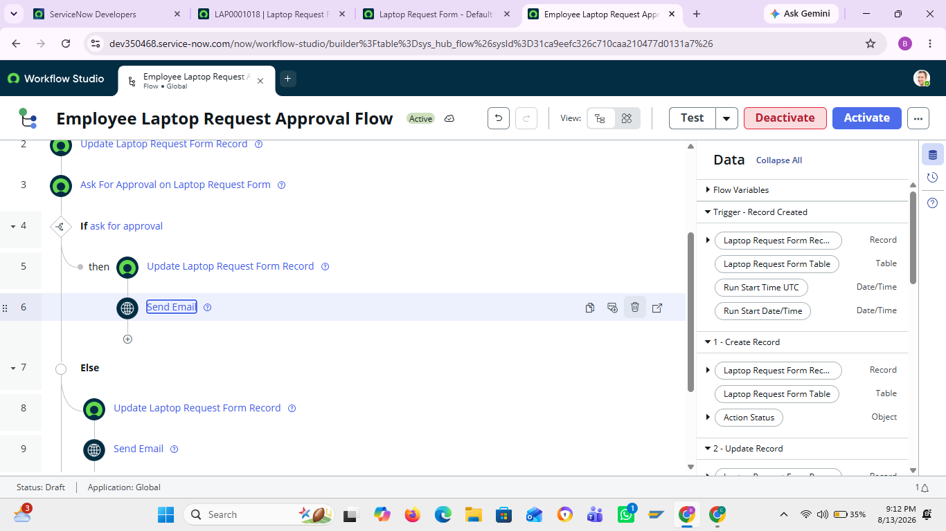

If Request is Approved — Flow
- Navigate: Flow Designer → Flow Logic → If.
- Set the condition: Approval State → Approved.
- Then: Use Update Record → Set Status = Approved.
- Add Send Email → notify the employee that the laptop request has been approved.
- Save and Activate the flow.
If the request is approved then it excutes only IF block this look like below
And also email should be send that is :
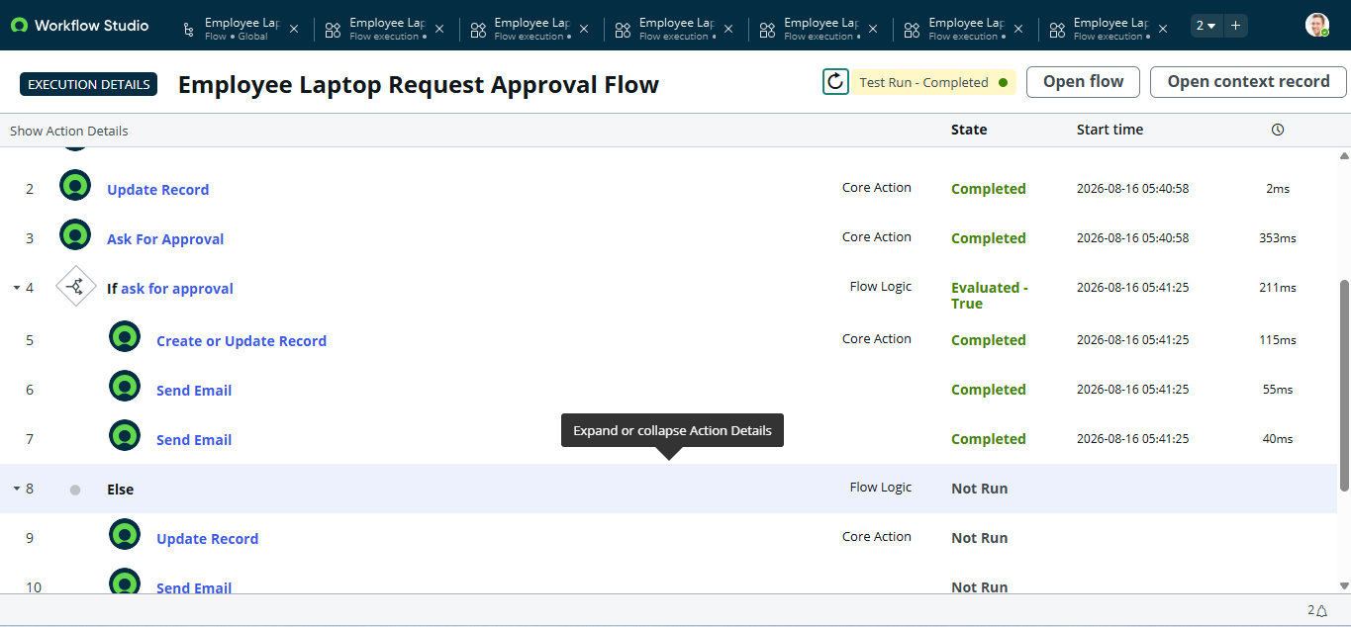
Approved email look like this :
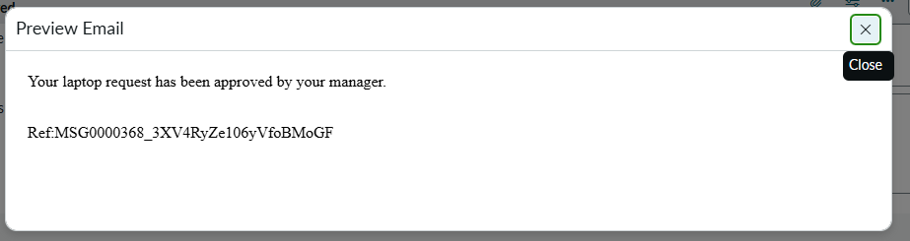
If Request is Rejected — Flow
- Navigate: Flow Designer → Flow Logic → If.
- Set condition: Approval State → Rejected.
- Then: Use Update Record → Set Status = Rejected.
- Add Send Email → notify the employee about the rejection.
- Save and Activate the flow.
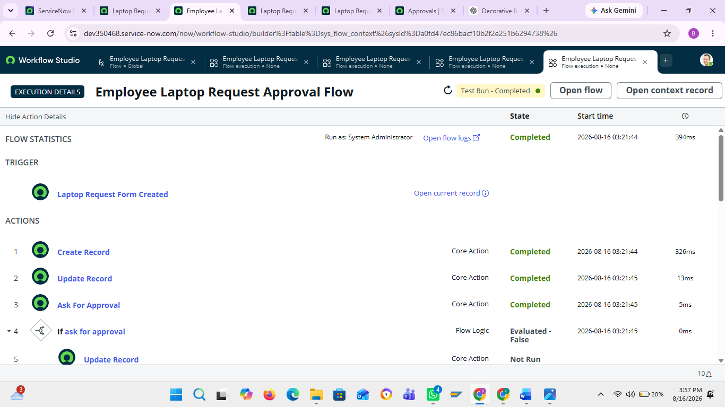
It excutes else block that look like this :
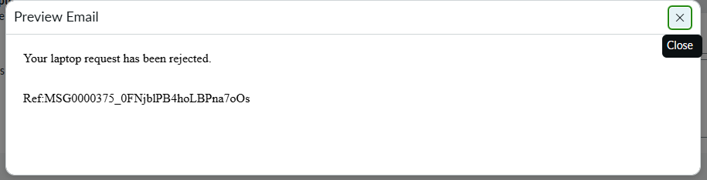
The rejected email look loke this .
Final Flow
Navigate: Flow Designer → Laptop Request Flow
Flow Process:
Request Created → Status: Pending Approval → Manager Approval → If/Else
- Approved → Status: Approved → Send Approval Email → End
- Rejected → Status: Rejected → Send Rejection Email → End
This completes the automated Laptop Request Management approval process

Business Rule – One Laptop Request Per Year
Purpose:
To ensure an employee can submit only one laptop request per calendar year and prevent duplicate requests at the backend level.
Navigation:
All → System Definition → Business Rules → New
Configuration:
- Name: Laptop request BR
- Table: Laptop Request form
- Enable Advanced
- When: Before
- Enable Insert
- Go to the Advanced section.
- Add a script that checks whether the requester already has a laptop request in the current calendar year.
- If a request exists, stop the new record and display an error message.
Business Logic – Short Flow
New Laptop Request → Check Requester → Check Current Year → Existing Request?
- No: Allow the request to be submitted.
- Yes: Block the request and show an error message such as “You have already submitted a laptop request this year.”
This ensures the one-laptop-request-per-employee-per-year policy is enforced automatically at the backend level.
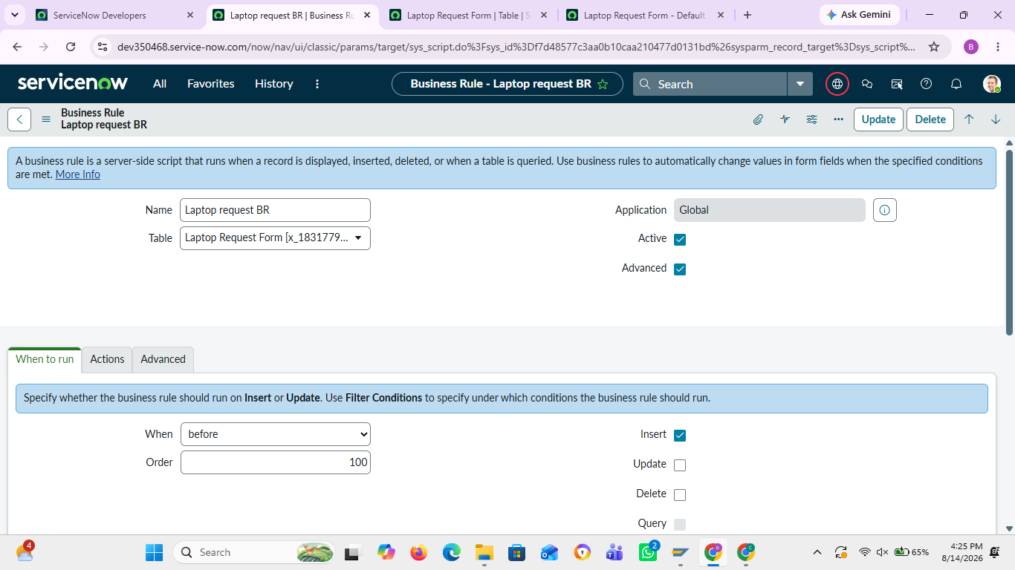

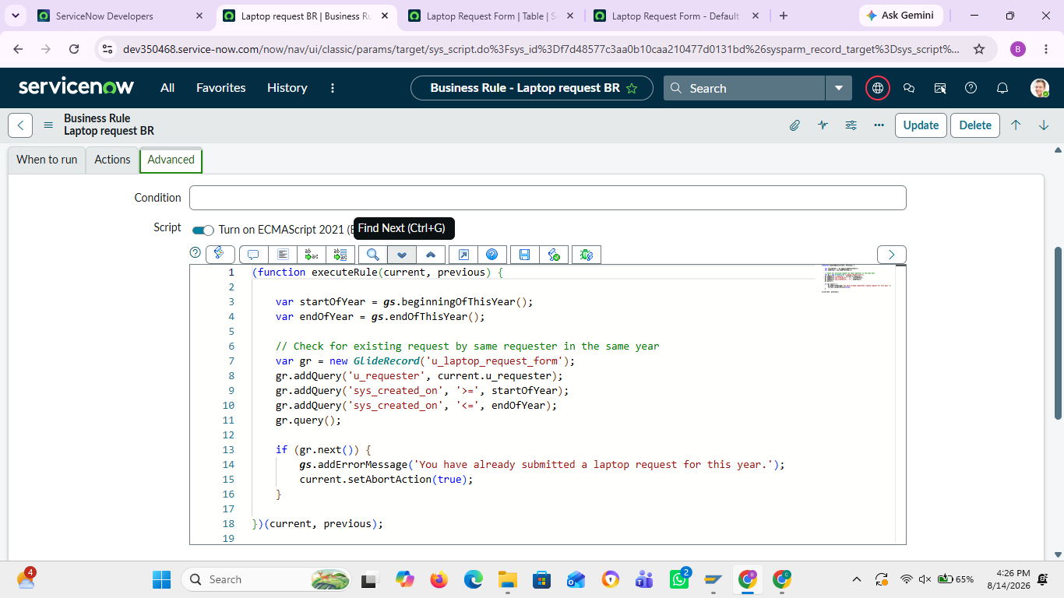

Duplicate Request Validation
When an employee tries to submit a second laptop request in the same calendar year, the Business Rule checks the existing requests for that employee.
If a duplicate request is found, the system blocks the submission and displays an error message:
“You have already submitted a laptop request this year. Duplicate requests are not allowed.”
Flow:
Submit Request → Check Existing Request → Duplicate Found → Error Message → Request Not Created
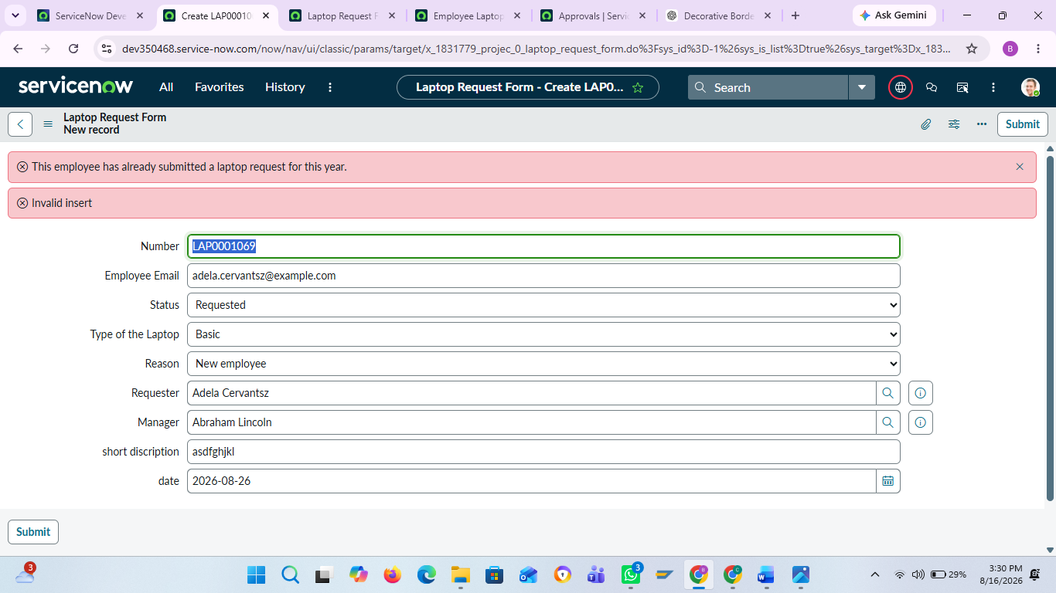

Role-Based Access Control
Purpose:
To control access to the Laptop Request Management application based on user roles.
Navigation:
All → User Administration → Roles → New
Create the following two roles:
Role Name | Purpose
it_manager | View-only access to laptop requests for IT managers
it_employee | Create and manage laptop requests for IT employees
Short Explanation:
- it_employee: Can create and manage their laptop requests.
- it_manager: Can view laptop requests for monitoring and approval purposes.
Access Flow:
User Login → Role Verification → Access Granted Based on Role → Application/Table Access
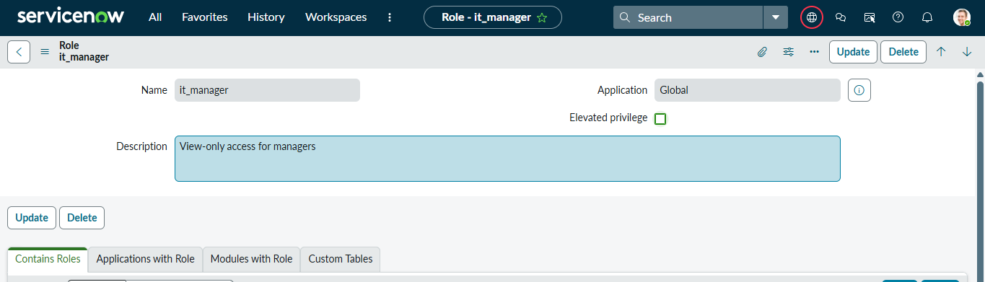

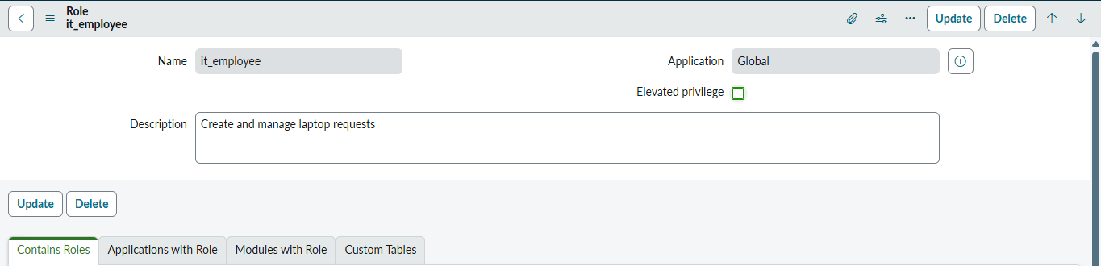

To manage access efficiently using groups.
- On All menus >> Search groups under users and groups select it.
- And create two new groups with given names and add members to those groups which are already created.
- Now add two roles to the two groups: manager to It manager role and Employee to It employee role.
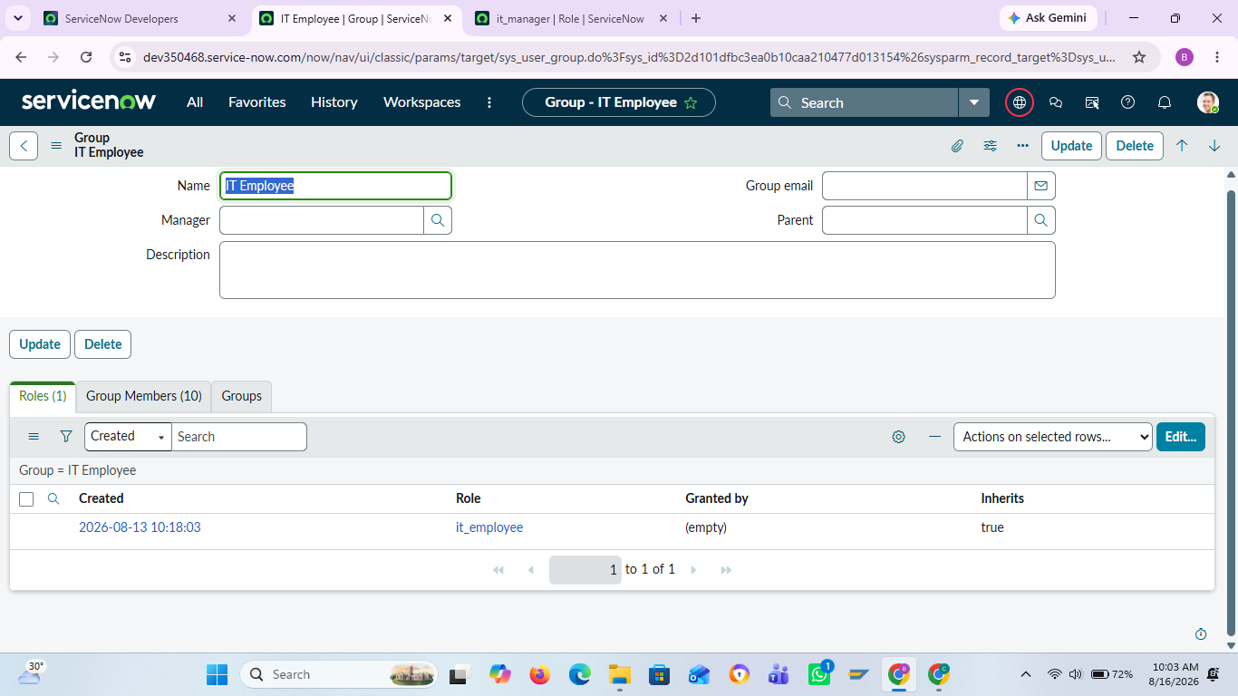
Also add some group members.
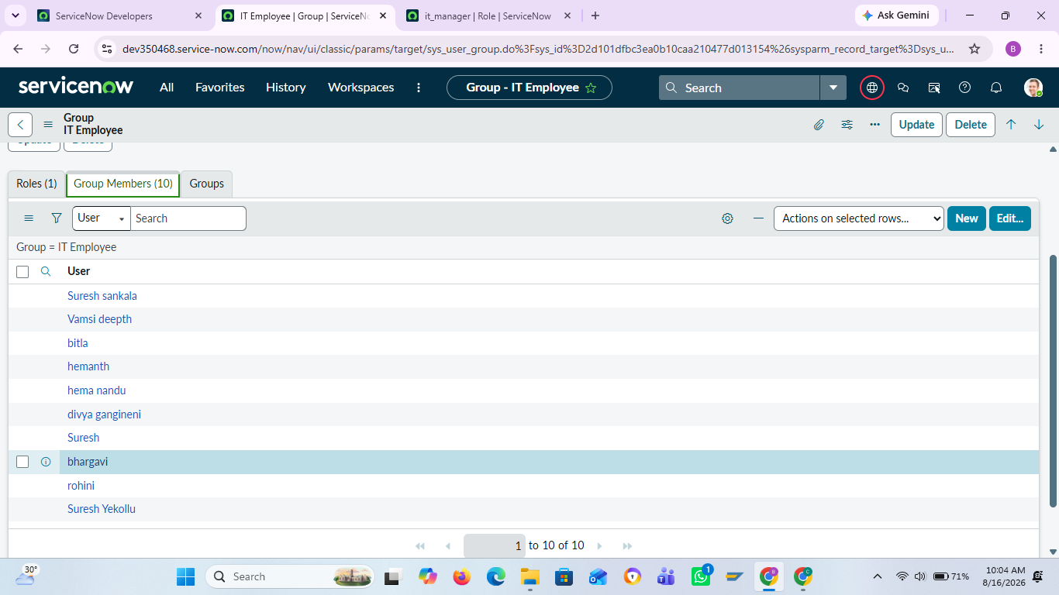
Next create another group and add some group members.
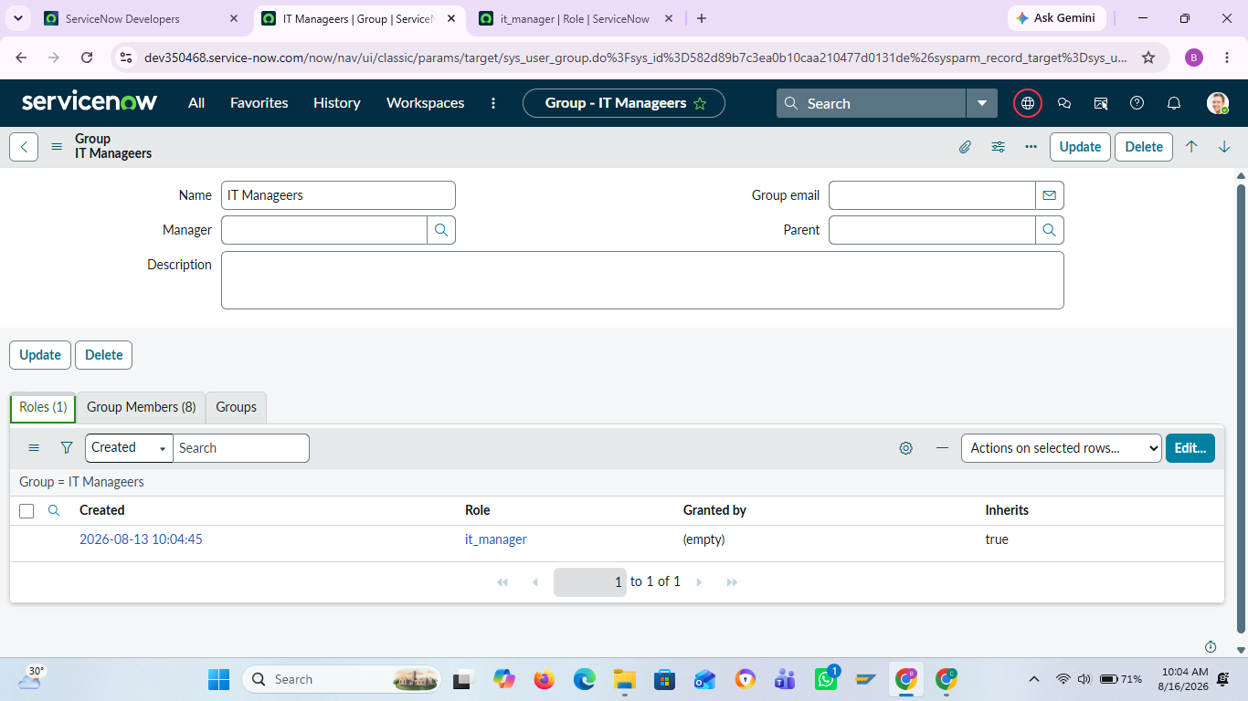
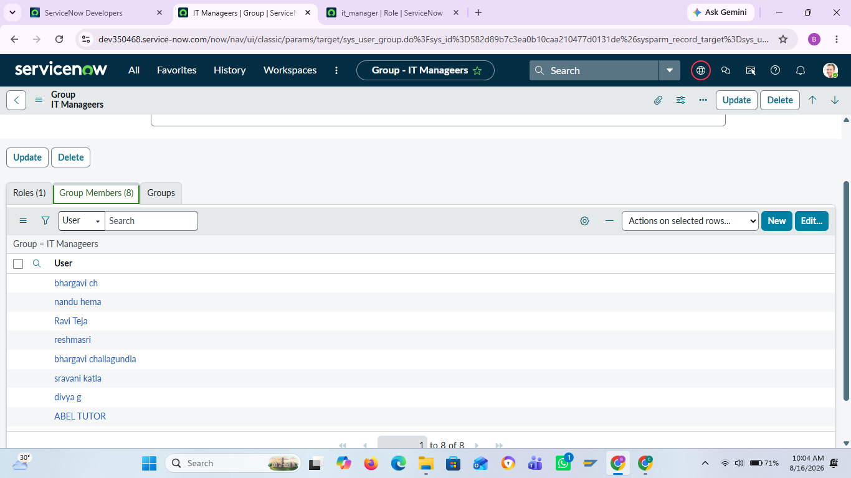
ACL creation
Purpose:
To restrict access to the Laptop Request Form based on user roles.
1. Manager Access – Read Only
- Role: it_manager
- ACL: Read
- Table: Laptop Request Form
- Result: Managers can view requests but cannot create or modify them.
2. Employee Access – Full Management
- Role: it_employee
- ACLs: Read, Create, Write
- Table: Laptop Request Form
- Result: Employees can create, view, and edit laptop requests.
Navigation in ServiceNow
System Security → Access Control (ACL)
- Click New.
- Select Type: record.
- Select Operation: Read.
- Select Table: Laptop Request Form.
- Add role: it_manager.
- Click Submit.
Then create three ACLs for employees:
System Security → Access Control (ACL) → New
- Read → Laptop Request Form → it_employee
- Create → Laptop Request Form → it_employee
- Write → Laptop Request Form → it_employee
ACL Design
Use Table-level ACLs with the format:
tablename.none
This provides consistent access control across the entire Laptop Request table.
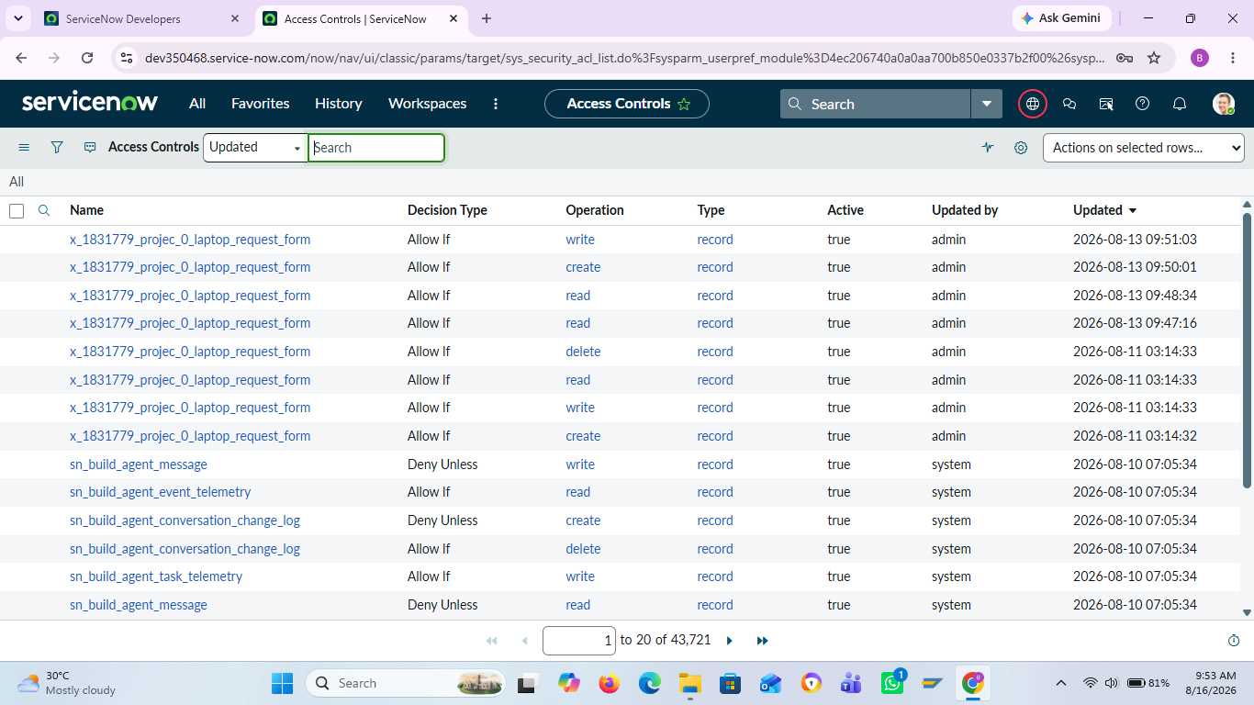
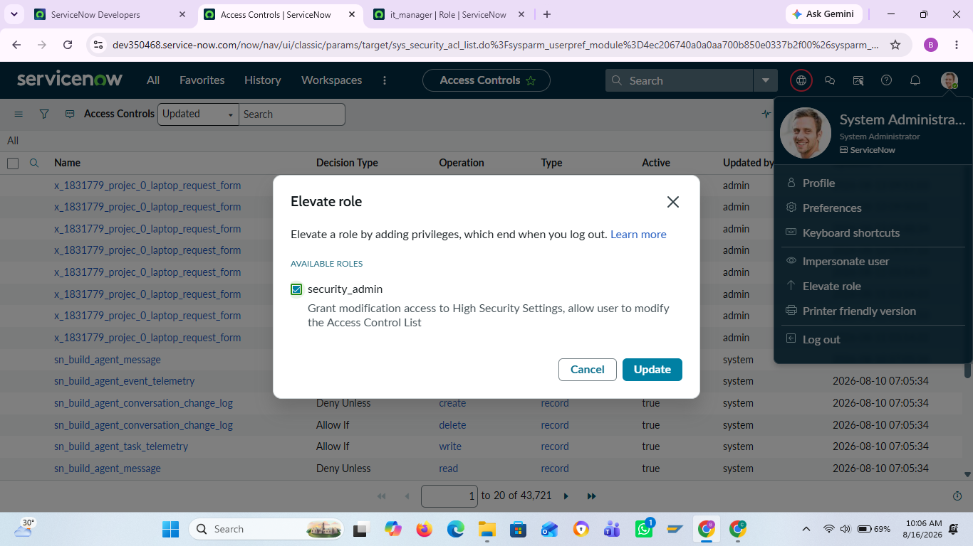
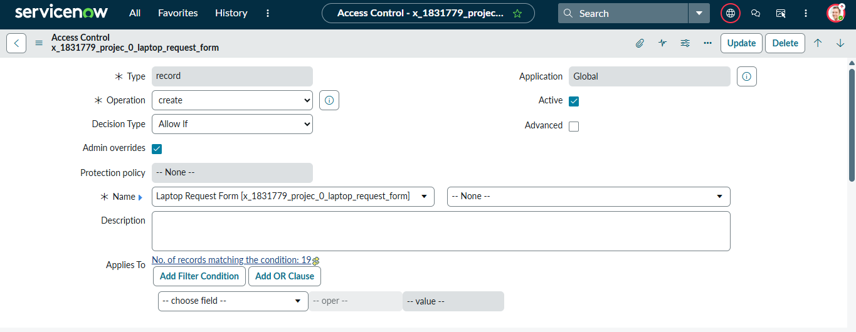
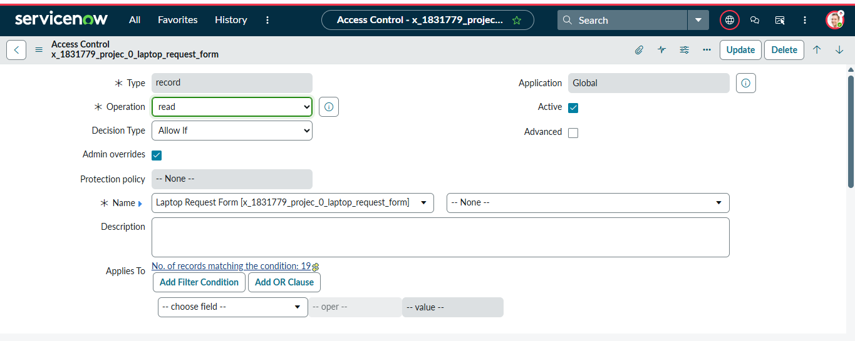
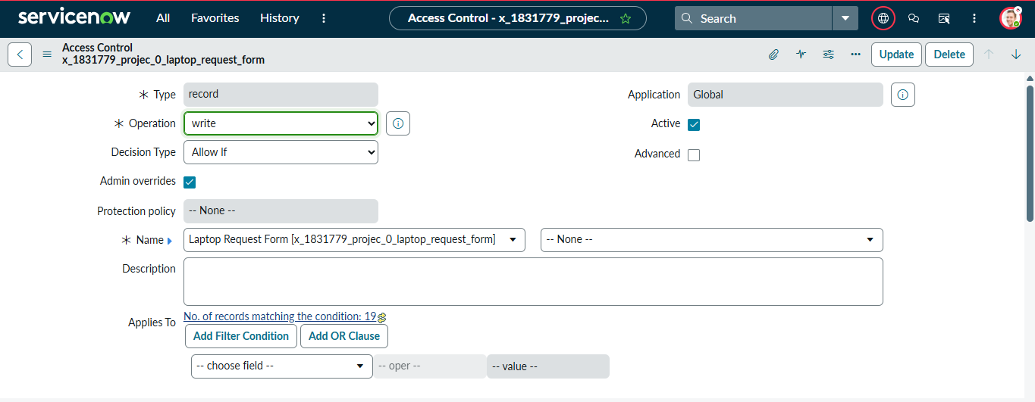
Opened HR Onboarding Application Update Set
Verified inclusion of:
Custom Application (Project Application)
Laptop Request Form table & fields
Record Producer
Business Rules
ACLs
Flow Designer approval workflow
Email notifications
Performed Update Set Preview
Resolved conflicts.
Committed update set to target instance after changing state to complete and export to xml.
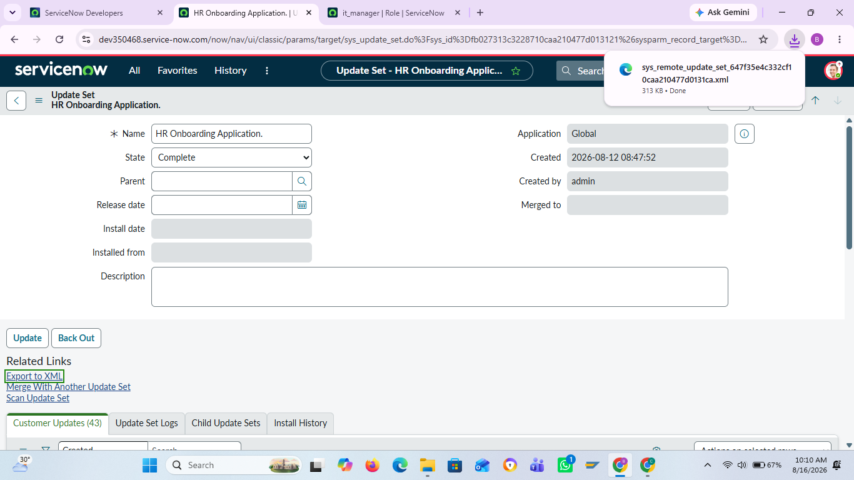
Conclusion
The Laptop Request Management System was successfully developed in ServiceNow to automate and streamline the laptop request process. The system manages request creation, manager approval, status tracking, notifications, duplicate-request validation, and role-based access control. Employees can create and manage their requests, while managers have controlled read-only access. Overall, the project improves security, efficiency, transparency, and request management within the organization.

